TO: UFV Student Union Society

FROM: Thomas Ware Club Presidents

DATE: December 12, 2021

SUBJECT: Research Report Solution Calculator Club

Research Report Assignment

Examining calculators and there use among students

Since the dawn of civilization, humans have had a need for devices to help manage laborious tasks, and as the scale of society continues to grow these devices have played a pivotal role. The rate at which these innovations can be summed up in a **brief history** **of the calculato**r as an example.

The first calculation device known was the **Abacus.** Invented in China around the **2nd century B.C**. However, Abacus-like devices are first attested from ancient Mesopotamiaaround **2700 B.C.**  A Handheld counting device used to add and subtract and store the current state of the computation. Constructed of Rods(rows) of 10 beads supported with a frame. Each row represents a power of ten. The introduction of the **Hindu-Arabic notation**, with its place value and zero, gradually replaced the abacus in the **17th century.** The abacus survives today in the Middle East, China, and Japan, but it has been largely replaced by electronic calculators.

The Renaissance was a creative time that brought new marvels into the world such as Mechanical Gear Driven Calculators. A ***Clock*** and the **Astrolabe** are examples of the early mechanical devices used to calculate time, day, year and position. In **1642** The **First Calculator** Invented by Blaise Pascal. Performed calculation through clockwork-type of mechanism. Pascal Later had a computer language named in his honor even though the device he invented had flaws.**The Step Reckoner** inventedbya mathematician-philosopher,**Gottfried Wilhelm von Leibniz (1671)** . Leibniz Step Reckoner expanded upon Pascals Machine and did multiplication by repeated addition Before the Step Reckoner calculations were carried out with Precomputed Tables by human computers.

“...it is beneath the dignity of excellent men to waste their time in calculation when any peasant could do the work just as accurately with the aid of a machine.”

Gottfried Wilhelm von Leibniz (1671**)** mathematician-philosopher

Leibniz machine worked a lot like an odometer in a car. Forward stepping for addition. Stepping refers to the gear move to the next power of 10 like in and Abacus to the next row of beads. Although an odometer does not go backwards conceptually this would be subtraction. Division is just the subtraction of the divisor from the dividen until the divisor can no longer be subtracted resulting in a Quotient and remainder. Likewise Multiplication is repeated additions.

Tabulating Machines could be used to solve complex problem in war for example calculation in targeting Cannons or large scale guns (the range table)

“The problem was. If you changed the design of the cannon or shell, a whole new table had to be computed, which was massively time consuming and inevitably led to errors.”

Babbage,(1822). Note on the Application of Machinery to the Computation of Astronomical and Mathematical Tables.

**The Difference Engine** was one of Charles Babbage’s inventions not completed until 1991 by historians. Which proved to work approximated polynomials. Polynomials describe the relationship between several variables, Polynomials used to approximate logarithms and trigonometric functions.

“At each increase of knowledge, as well as on the contrivance of every new tool, human labour becomes abridged.”

Charles Babbage(1827.)

During the building of The Difference Engine Babbage conceived of **The Analytical Engine.** Unlike the difference Engine, Step Reckoner and all other computational devices before it - the Analytical Engine was a “general purpose computer”.

Could used for more than just one particular computation also had memory and a primitive printer.

The foreshadowing of computer programming, **Ada Lovelace**  a mathematician and first programmer wrote hypothetical programs for the Analytical Engine.

“A new, a vast, and a powerful Language is developed for the future use of analysis. ”

**Ada Lovelace(1842)**

Babbage inspired the first generation of computer scientists and was considered the Father of computing. At the end of the 19th century special use in Sciences and engineering. Not seen in business and government until.1818.

Population growth lends to the problem of data entry because a census is required every 10 years.Government census took 7 years to compile and before completed was already out of date. The 1819 census would take 13 years to compute.

**Herman Hollerith’s (1819) Electro Mechanical Tabulating Machine**  featured **Punch Cards.** Hollerith’s machine was roughly 10x faster than manual tabulations, and completed the Census in just two and a half years - saving the census office millions of dollars.Businesses saw the value in boosting profit and improving labor intensive tasks by using the machine for data entry in accounting, insurance appraisals and inventory. Hollerith founded the Tabulating Machine Company that merged with other tabulating machine companies to become **IBM**(International Business Machine Co.)

The 1940’s was the era of Room Scale Computers Starting with the **Harvard Mark I** **(1939-1944).** This **Relay** D]driven machineran simulations for the Manhattan Project. Innovation was the **Relay(1940)** Relay lifespan 10yrs wear and tear and higher probability of failure the more relays are in the circuit. The mechanical arm inside of the relay has mass, and therefore cannot move instantly between open and close states **The Enigma Machine aka the Bombe (1941) Alan Turing** Cipher cracking machine. **The Colossus MK 1 (1943). Tommy Flower's machine** used **The** **Vacuum Tube.** 10 Colossus were built to break codes using a plug board like telephone switch board.to program.**The** **ENIAC (1945)** Electronic Numerical Integrator and Calculator Designed by **John Mauckly and J, Presper Eckert**. ENAIC was a general purpose programmable Electronic computer.

Moving closer to the modern age earlier Inventions such as Relay, Vacuum Tube design lead to newer innovations of Diodes, Transistors, and the ICs. **Thermionic Valve or Vacuum Tube(1904) John Ambrose Fleming** Electrical Engineer and Physicist. Revised as a **Triode Vacuum Tube(1906) Lee DeForest .** In **1947 Bell Laboratory’s William Shockley, Walter Houser Brattain and John Bardeen** invented the **Transistor**. An electronic switch is also called a solid state component. **1950** Vacuum Tube computing reached it Zenith. After **1960’s** the shift form electromechanical switching to Electronic switching **IBM** transitions to **transistors** and the home computer revolution begins: The Birth of Silicon Valley, Shockley Semiconductors and Fairchild Semiconductors whos’ employees Created INTEL.

We can speak about the history of Calculators without mentioning Computer Science and Levels of Abstraction. In computers, an “on” state when electricity is flowing, represents true. The “off” state, no electricity flowing. Represents false. This is called Logic also referred to as **Boolean Algebra**. Named after **George Boole** Self Taught Mathematician in **1815**. Boolean logic goes beyond Aristotle’s Logic. Boole’s approach allowed truth to be systematically and formally proven, through logic equations which he introduced in his first book,””The Mathematical Analysis of Logic”.”

**NOT AND OR Logic :**

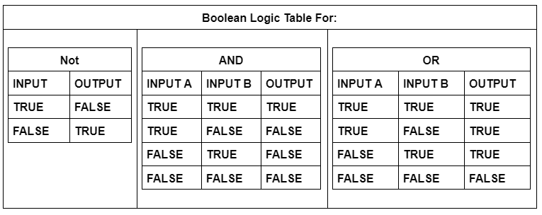**Figure 1.1**

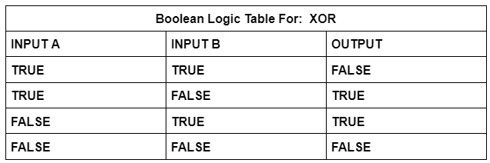

**Figure 1.2 the soup or salad logic**

**TTL (Transistor-Transistor Logic)** is the first layer of abstraction where these simple transistor circuits become logical blocks representing the NOT AND OR Logic Gate, Introducing new symbols to use in building more complex functions. **Electronic Engineers**  work at the Symbolic gate level of abstraction This layer is where we move from power switching to representing data as TRUE & False.

We count using the ***Decimal*** called Base 10 values 0 to 9. Computers, however, use

switching on or off represents two states of ***Binary Code*** or Base 2. These **Binary** values are called **Bits (0, 1) 4 bits is a nibble, and 8 bits is a byte.**

Representing 16 & 32 bit We **Floating Point Numbers (IEEE)** standards. The first bit is the Sign Next 8 Bits are the Exponent the next remaining bits store the Significand.

Eg 01000100000111000111100110011010=625.9

Computers store letters of text as numbers. **The Baconian Bilateral Cipher: Sir Francis Bacon** devised a cipher thatwas 5 bits to store the values of the 26 letter alphabet. 5 Bits can store 32 possible values but not for numbers, punctuation and special characters. **ASCII (American Standard Code for Information Interchange) 8 bit encoding schema** was adopted.See ASCII Table for key codes. The main feature allowed the interoperability of networked machines. Encoding translation error named MOJIBAKE was solved with a universal encoding schema **UniCode (16 bit )** allowing for Multi-language special character inputs.

This is the time in the story when exponential growth or rather miniaturization of circuits come into play. The **Integrated Circuit (IC) 74181 Arithmetic Unit(ALU)** handles all numeric operations in a computer All operations are really Additions In computers systems.Like Add one to a number is called an incrementation used for counting clock Cycles .

Input combination

0+0=0 1+0=1 0+1=1 1+1+10 (Binary 2 ) or 0 with a carry

1=TRUE 0=FALSE

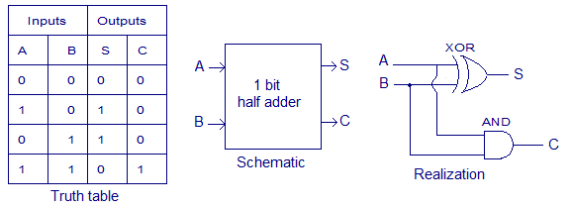

**Figure 1.3 Half Adder**

Abstracting the HALF ADDER into a Block INPUT(S) A, B and OUTPUT(S) SUM, CARRY

**FULL ADDER Table**

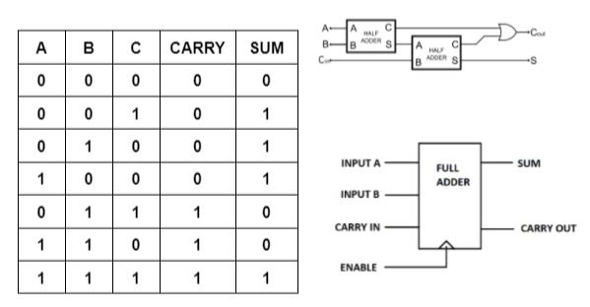

**Figure 1.4 Full ADDER**

**Building an 8-BIT ADDER:**

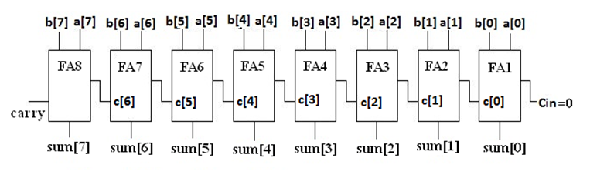

**Figure 1.5 8-BIT RIPPLE CARRY ADDER**

OverFlow error if carry out on the last full adder. The example was the 8 bit Game PacMan level 255 completes then level 256 has code glit overflow into the display. Making the game next to impossible to play.

**8-BIT LOOK AHEAD CARRY ADDER??????????**

8 Operations Circuits:

| ADD | A and B are summed |
| --- | --- |
| ADD with CARRY | A and B and a Carry-In bit are all summed |
| SUBTRACT | B is subtracted from A (or vice versa) |
| SUBTRACT with BORROW | B is subtracted from A (or vice versa) with borrow (carry-in) |
| NEGATE | A is subtracted from zero, flipping its sign (from - to +, or + to -) |
| INCREMENT | Add 1 to A |
| DECREMENT | Subtract 1 from A |
| PASS THROUGH | All bits of A are passed through unmodified |

**Figure 1.6**

**Logic Unit:**

Performs logical operation like AND OR NOT.

Numerical tests

A Circuit that test if output is 0

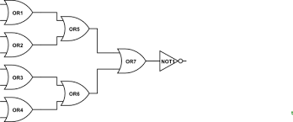

**Figure 1.7 Zero (Bit) Test Flag**

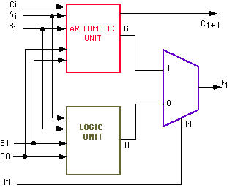

**Figure 1.8 Arithmetic & Logic Unit**

**AND-OR Latch**

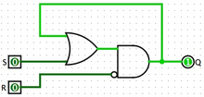

**Figure 1.8**

**Gated Latch (D- Latch)**

**Write to memory**

**Read from memory**

**Registers** ia a group of latches, which holds a single number, and the number of bits in a register is called its width.

**RAM or Random Access Memory**

**Persistent Memory**

8 16 32 64 bit registers

**16X16 Latch Matrix**

**1 to 16 Multiplexer for Row 1 to 16 Multiplexer for columb**

**Demultiplexer**

32 & 62 bit

**Memory Addresses**

Communication Code Languages (Binary)

Instruction sets Hexadecimal Code

**(1960’ to present date)Sharpe vs Casio**

**Innovations:** Thin Film technology such as **Solar Cell** and **LCD** (Liquid Crystal Display). As well as reduce control systems i.e. button inputs. The competition between these two companies in Japan led to the miniaturization of many componentes.

Goals of the club:

To have Coffee houses meetings in the spirit (orIgins of clubs) to facilitate become better students.Share knowledge (learn by teaching). Gain understanding math concepts and be able to formalise solutions to problems (Layers of abstraction)

Perhaps also share Fun Fact(s) like:

* + **Richard Braithwaite (1613)** book called *The Yong Mans Gleanings*

People the performed calculation were designated “Computers

In the early 1800’s the term computer started to refer to the device.

* + The **computersystem bug** was coined by **Grace Hopper** in **1947** because there was literally a moth in the computer relay..

“From then on when anything went wrong with a computer, we said it had bugs in it.” Grace Hopper(1947)

* + The Birth of Silicon Valley
  + 339 calculators

The structure or organizational model

**Example:**

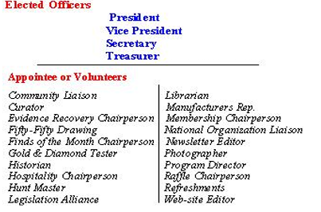

**(**supported by other successful examples**)**

**Figure 1.1**

**Our Club Structure:**

**Club President, Members and Volunteers**

**Why is the club important ?**

(Use it to explain the importance of a club like yours to a school like ours )

**Ask yourself: what does your club do for its participants? Use your research to justify your claims.**

Our Club Helps identify and use methodologies that work best for each student to better their success in the chosen field of study. By examining calculator use among students with and without disabilities.The Spiral Method, The Mastery Method and The Incremental Method are current methodologies used in teaching. Comparing the teaching method to the students' needs, can we see that use of calculators have a negative or positive affect on teaching math concepts to people with learning disabilities?

There seems to be a great debate when it comes to the use of technology in the educational process for learning mathematical concepts. The Debate is does technology use benefits students with disabilities and students who struggle with math.and should Calculator and Other technology use in the classroom

Baxter, & Robinson, (1999). “Proponents of calculators believe using calculators can foster conceptual development and reduce both students’ computational error and fear of mathematics.”

What is **Universal Design for Learning (UDL)** system and can it help solve the problem in other teaching methods?

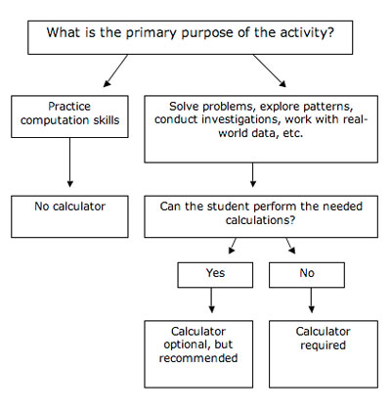

**Figure 2.1 Universal Design for Learning (UDL)**

<http://www.ldonline.org/article/19274/>

.**There is another side of the debate:**

How technology use in high school affects college performance?

Does technology usage and student collaboration and plagiarism?

What does using technology do to the understanding for the student?

**Teacher Perspectives on Technology Use**

Conclusion

Task to complete:

* Using **a minimum of 5 sources (3 scholarly, peer-reviewed)** write a research report that details your club and justifies your club based on the research
* **Use the research to write a** **brief history**  **of the “topic”.**

Topic: Examining calculator use among students with and without disabilities.

* **Goals of the club**
* **The structure or organizational model**

**Explain** (with the support of academic research)

* **Why is the club important ?**

(Use it to explain the importance of a club like yours to a school like ours )

* **Ask yourself: what does your club do for its participants? Use your research to justify your claims.**
* **Cite:**Reference

Reference to cite:

From:

https://homeschoolgameschool.com/every-homeschool-math-curriculum-weve-ever-used/

What are the different math curriculums?

There are three types of math curriculum, with the majority of math curriculum being **spiral or mastery**. The third type, incremental, combines spiral and mastery. The Spiral Method introduces math to the kids in a specific order, with each new concept building on the last one

**The Spiral Method** introduces math to the kids in a specific order, with each new concept building on the last one. In the spiral method children move on the the next concept even if they don’t have a full understanding of the previous concept because the concept will be presented as review in future lessons. Critics of the spiral method say it’s not appropriate to move to a new lesson if the concept isn’t mastered, yet proponenets of the spiral method say it doesn’t bog down children by demanding mastery before moving on.

**The Mastery Method** presents the child with a lesson and concept that must be mastered before moving on to the next idea. For example, in a mastery math curriculum a child cannot learn division until they have mastered addition, subtraction, and multiplication in that order. Critics of the mastery method feel that it demands too much, moves too slowly, and can be unmotivating and boring. Proponents of the mastery method feel that it is a more complete way to learn math and that children are harmed if they move too fast.

**The Incremental Method** is a combination of spiral and mastery. With incremental math curriculum the student is presented with an idea with the goal of mastery, but the concept will keep popping up down the road for review, just like with spiral math curriculums. This is a tough one to define because it encompasses both styles and can lean toward either end. Because it’s not a consistently-used term in the homeschooling world, I will add it as appropriate below but also note whether the curriculum leans toward the spiral or mastery side.

**For in document citation**

Reference From:

[Educational Studies in Mathematics](https://www.jstor.org/journal/educstudmath) [Vol. 83, No. 3, July 2013](https://www.jstor.org/stable/i23434893) Examining calculator use among students ...

Baxter, & Robinson, (1999). Proponents of calculators believe using calculators can foster conceptual development and reduce both students’ computational error and fear of mathematics.

**Backing up clams from other reference**:

Reference From: https://medium.com/scholars-lounge/the-effects-of-calculator-and-technology-use-on-mathematical-academic-performance-d5b91b9a1e1e

When considering calculator and other technology use in the high school classroom, some say that students are just using their resources to solve problems (Crawford et al., 2016; Orellana & Barkatsas, 2017; Salani, 2016; Thomas & Muñoz, 2016). Others say that the students’ use of technology in their math classes enhances their understanding of underlying concepts (Crawford et al., 2016; NCTM, 2000; Orellana & Barkatsas, 2017).

## 

**Web Reference APA Style needed here**

Reference From: http://www.ldonline.org/article/19274/

## **Universal Design for Learning (UDL)**

Universal Design for Learning is an educational framework that optimizes opportunities for all individuals to gain knowledge, skills, and enthusiasm for learning (Meyer & Rose, 2002; Rose & Meyer, 2006; Rose, Meyer, & Hitchcock, 2005). The "universal" in Universal Design for Learning (UDL) does not imply one optimal solution for everyone, but instead underscores the need for inherently flexible, customizable content, assignments and activities, and assessments characterized by:

* Multiple representations of information — as there is no single method for the presentation of information that will provide equal access for all learners (Recognition Principle);
* Multiple methods of action and expression — as there is no single method of expression that will provide equal opportunity for all students (Strategic Principle); and
* Multiple means of engagement — as there is no single way to ensure that all children are engaged and motivated in a learning environment (Affective Principle).

The term "universal design" is borrowed from the architectural concept of the same name, which called for curb cuts, automatic doors and other architectural features to be built into the design to avoid costly after-the-fact adaptations for individuals with disabilities. UDL applies the same concept to learning — creating a curriculum with numerous built-in features to meet the learning needs of a wide range of students, including those with disabilities and special talents.



* References

The Latest from PBS Digital Studios:<https://www.youtube.com/playlist?list>...

## **APA Style Citation**

Charles Babbage Quotes. (n.d.). BrainyQuote.com. Retrieved November 28, 2021, from BrainyQuote.com Web site: https://www.brainyquote.com/quotes/charles_babbage_309718

